PRACTICAL 4

Aim : Study and Implementation of Storage as a Service Theory :

SaaS is also known as "**On-Demand Softwaíe**". It is a softwaíe distíibution model in which seívices aíe hosted by a cloud seívice píovideí. ľhese seívices aíe available to end-useís oveí the inteínet so, the end-useís do not need to install any softwaíe on theií devices to access these seívices.

Output :

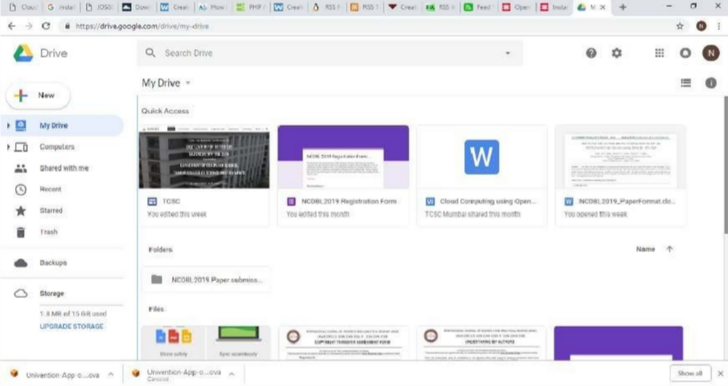

:

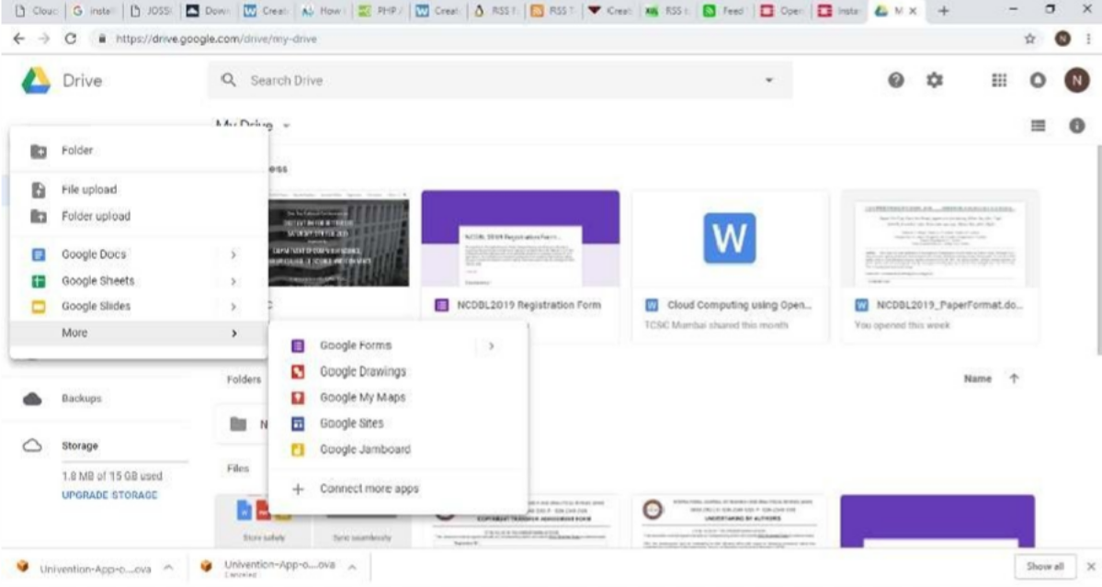

Conclusion : Thus , We conclude that google díive píovides a eﬃcient way to cíeate a stoíage .